**PRACTICAL No.5 [DEPTH FIRST SEARCH]**

**1.Write a Program to Implement Depth First Search without goal state using Python.**

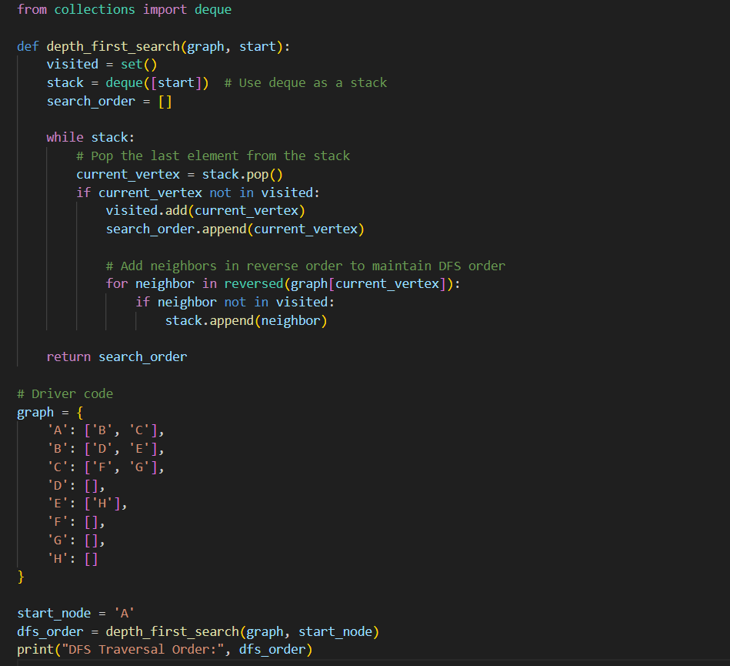

**OUTPUT:**

**2.Write a Program to Implement Depth First Search with goal state using Python.**

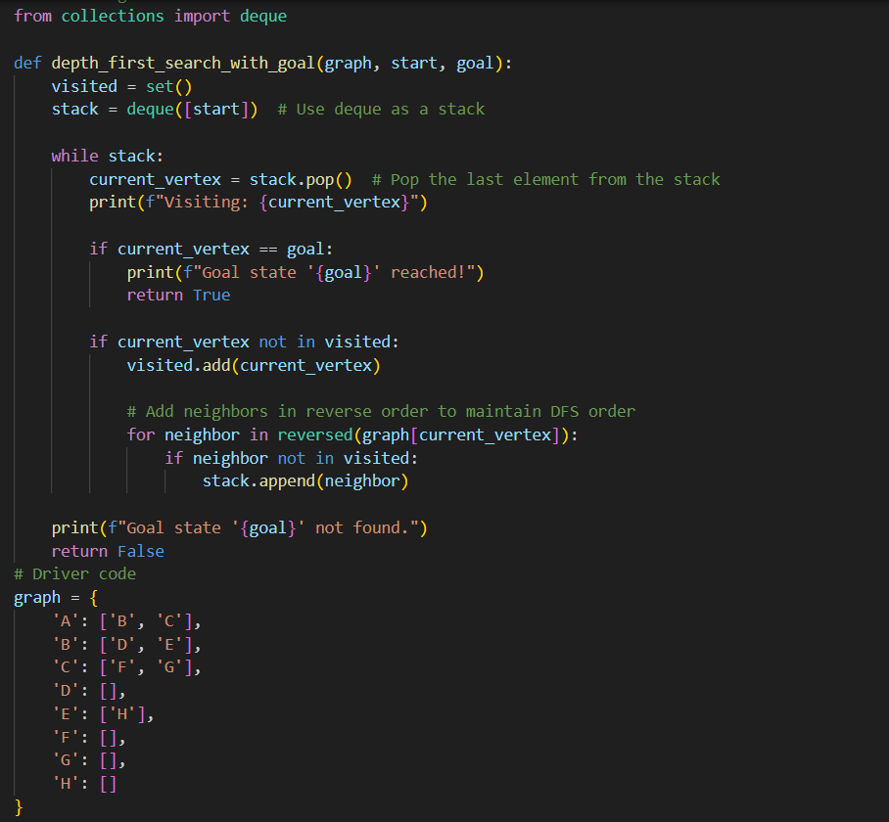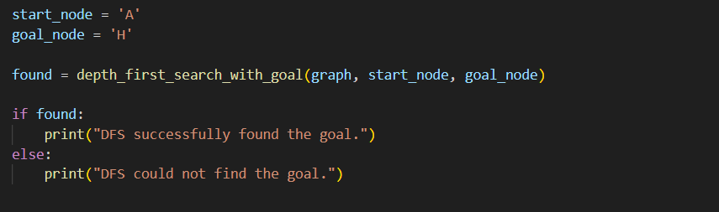

**OUTPUT:**

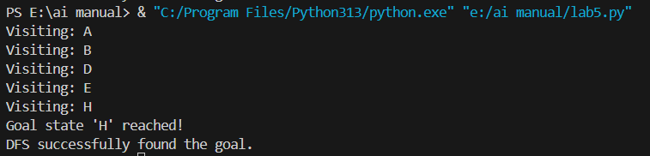

**PRACTICAL No.6 [UNIFORM COST SEARCH]**

**1.Write a Program to Implement Uniform-cost Search using Python.**

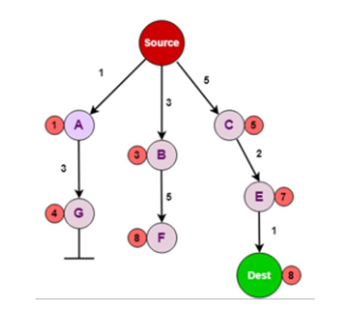

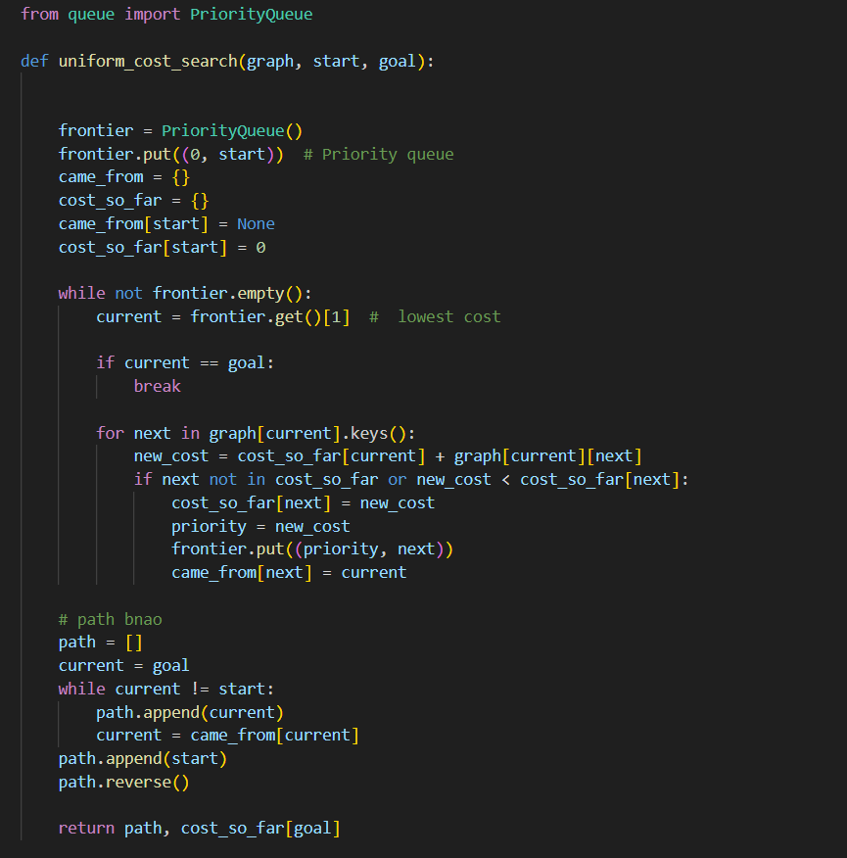

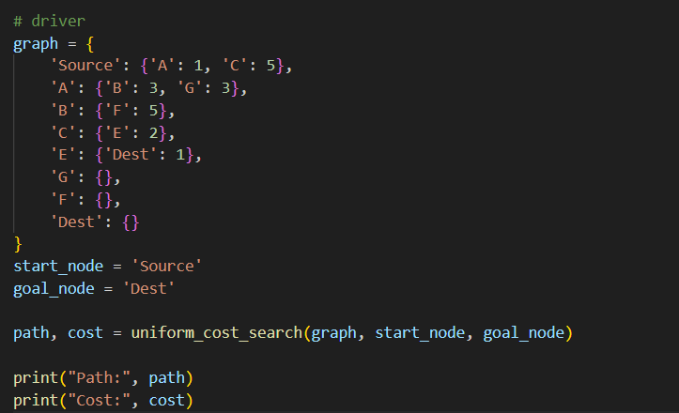

**OUTPUT:**

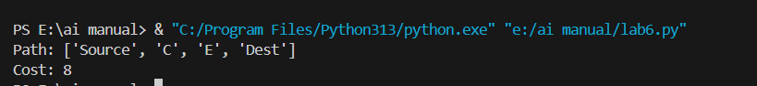

**2.Write a Program to Implement Uniform-cost Search using Python.**

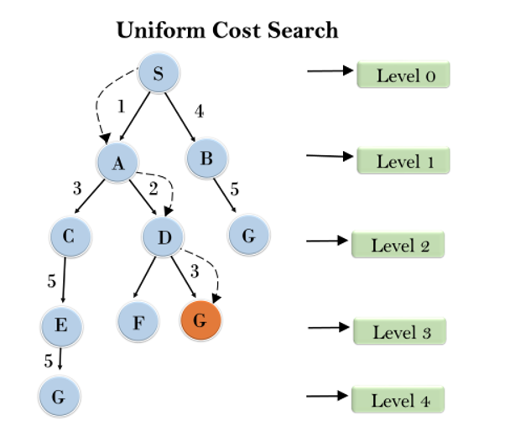

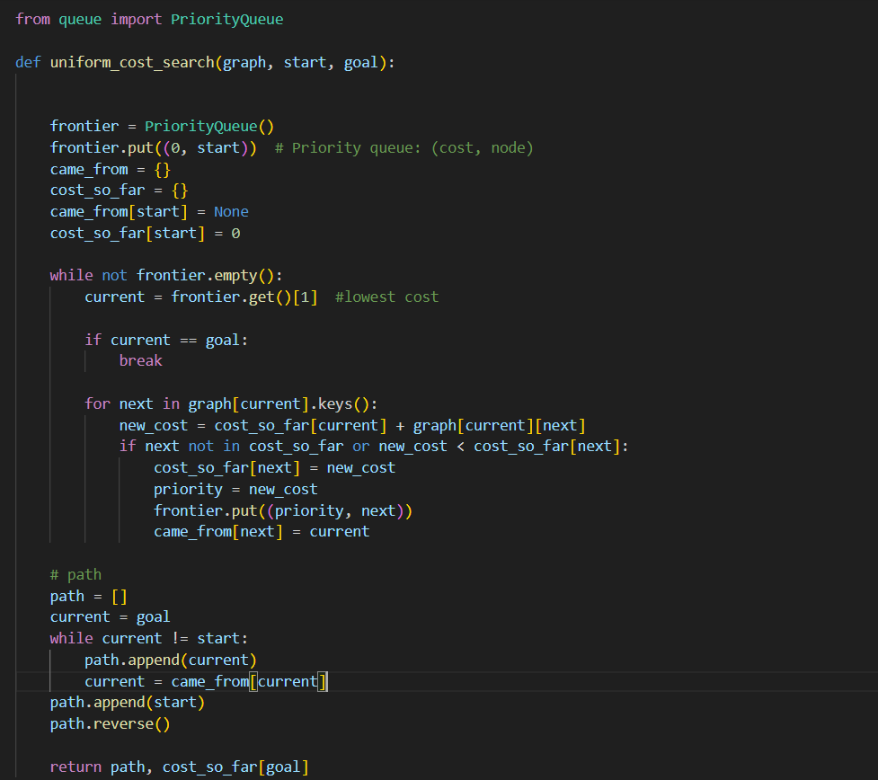

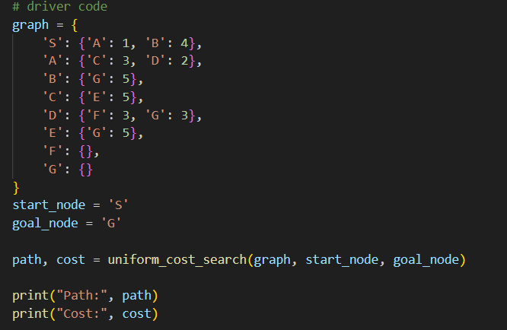

**OUTPUT:**



**PRACTICAL No.7 [BEST FIRST SEARCH]**

**1.Write a Program to Implement Best First Search without goal state using Python.**

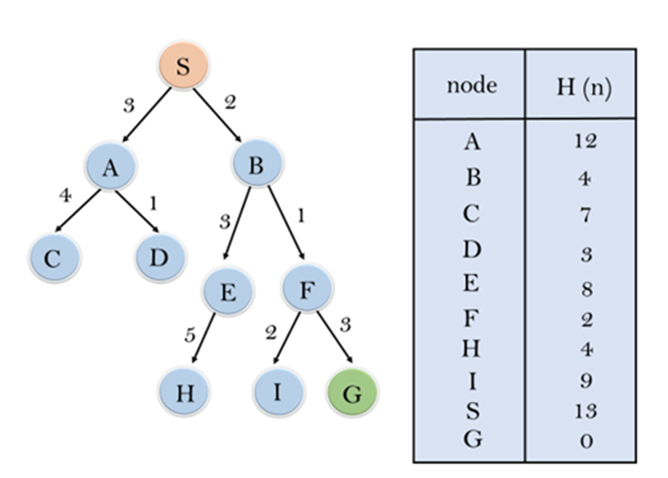

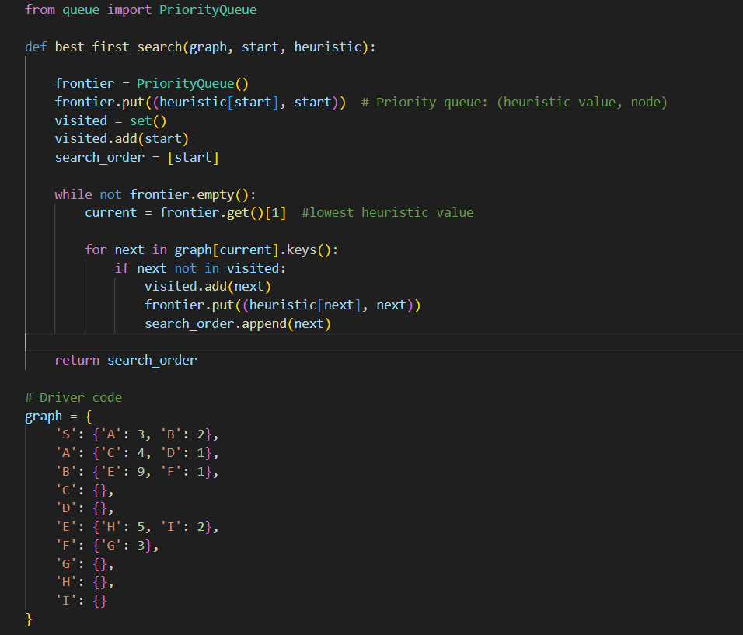

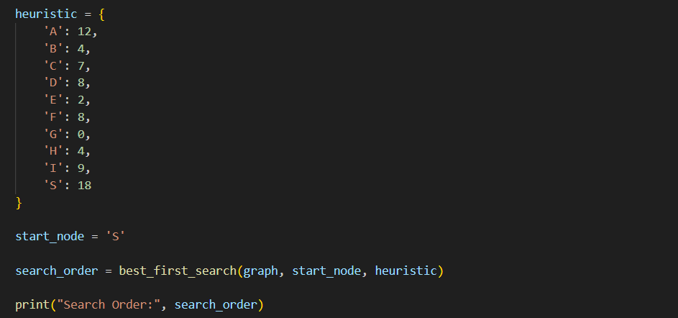

**OUTPUT:**



**PRACTICAL No.8 [A* SEARCH]**

Write a Program to Implement A* Search using Python.

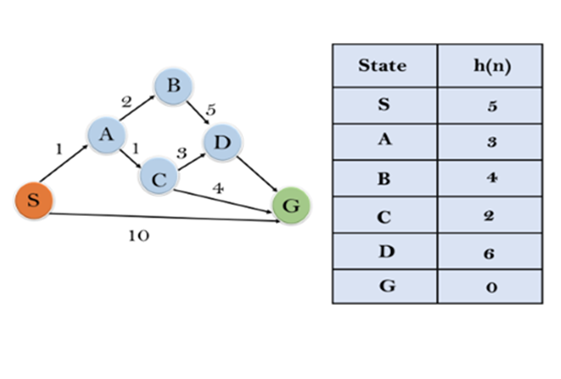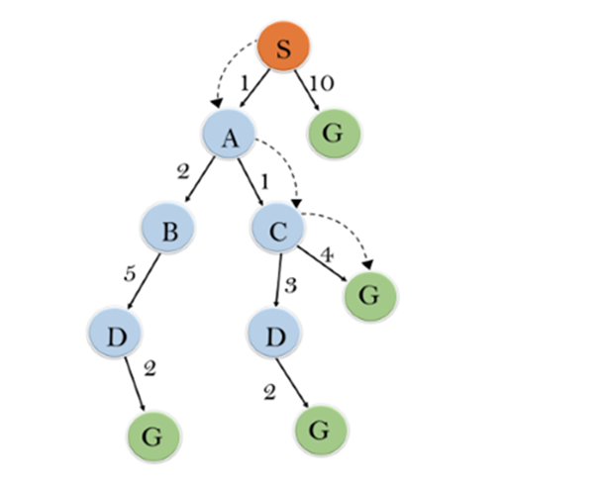

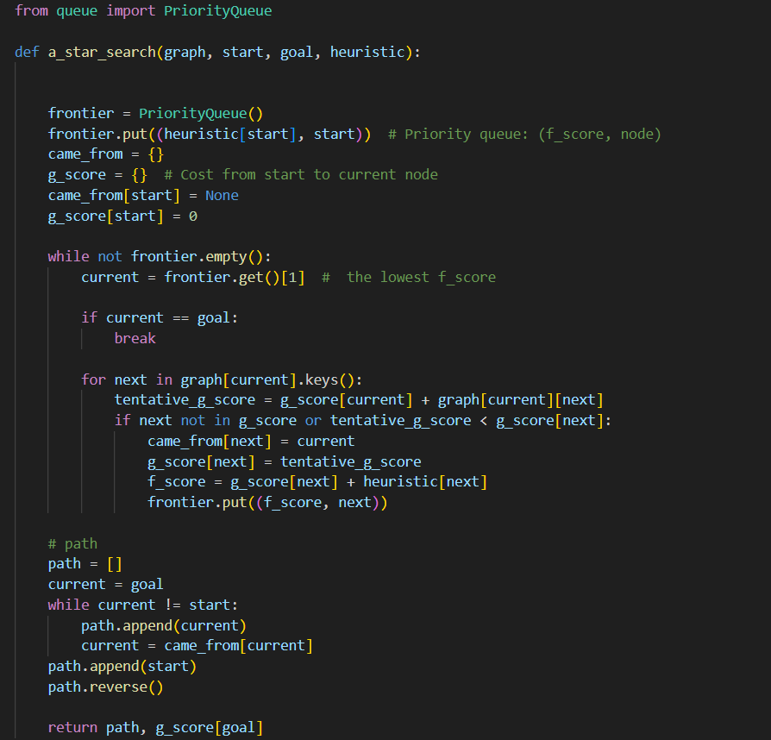

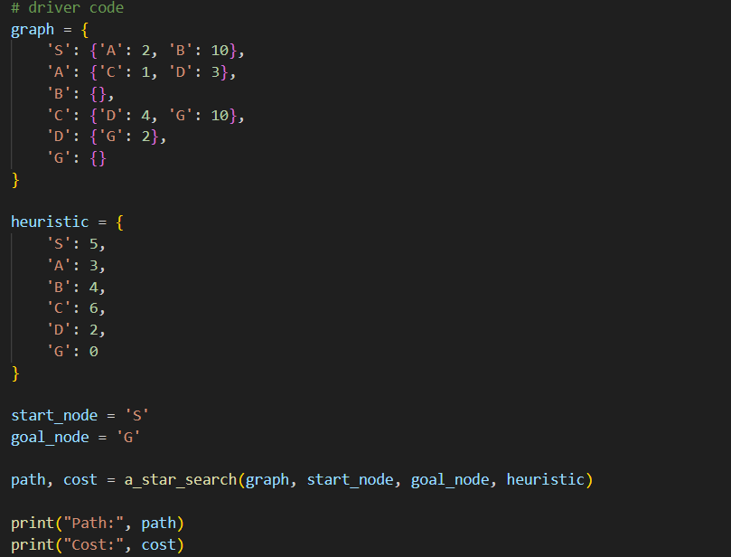

**OUTPUT:**

